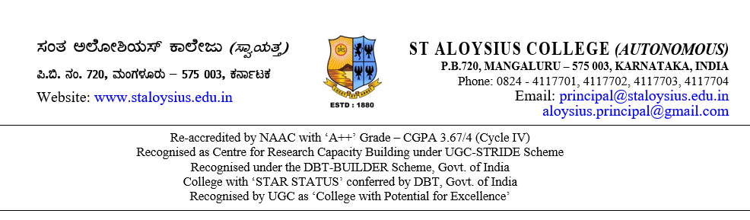

**TO WHOMSOEVER IT MAY CONCERN**

This is to certify that Mr / Ms ____________________________________________ bearing Reg. No. __________________ studying in VI Semester BCA, of our College during the academic year 2022–23 has done his / her project on the topic titled “___________________________________________________” for the purpose of partial requirements for the award of the degree of Bachelor of Computer Application (BCA).

He / She has collected information from us and has satisfactorily completed the project under our guidance during the period from January 2023 to May 2023. During this tenure, his / her conduct and character was found good.

Thanking You,

Yours truly

(Name & Signature)

Place:

Date: